H.T No
Regulations:
A19

Sreenidhi Institute of Science and Technology
(An Autonomous Institution)
Code No: 7P101 Date: 10-July-2021 (FN)

M.Tech I-Year I-Semester External Examination, July - 2021 (Regular & Supplementary)
MATHEMATICAL FOUNDATIONS OF COMPUTER SCIENCE (CSE & CS)

Time: 3 Hours Max.Marks:70

Note: a) No additional answer sheets will be provided.
b) All sub-parts of a question must be answered at one place only, otherwise it will not be valued.
c) Missing data can be assumed suitably.

ANSWER ANY 5 OUT OF 8 QUESTIONS. EACH QUESTION CARRIES 14 MARKS.

Bloom's Cognitive Levels of Learning (BCLL)

Remember | L1 | Apply | L3 | Evaluate | L5
Understand | L2 | Analyze | L4 | Create | L6

 |  |  | BCLL | CO(s) | Marks
1. | a) | Construct the truth table for (p ↔ q) ∨ (¬q ↔ r) | L2 | CO1 | [7M]
 | b) | Find the PCNF for ¬ (¬p ∨ q) ∨ (r →¬s) | L3 | CO1 | [7M]
2. | a) | Show that s ∨ r is tautologically implied by (p ∨ q) ∧ (p → r) ∧ (q → s) | L4 | CO2 | [7M]
 | b) | Use rules of inference to show that if ∀x(P(x) ∨ Q(x)) and ∀x((¬P(x) ∧ Q(x)) → R(x)) are true, then ∀x(¬R(x) → P(x)) is also true, where the domains of all quantifiers are the same. | L4 | CO2 | [7M]
3. | a) | Let R denote a relation on the set of ordered pairs of positive integers such that (x, y) R (u, v) iff xv = yu. Show that R is an equivalence relation. | L3 | CO3 | [7M]
 | b) | Draw the Hasse diagram for inclusion on the set P(S) (Power set), where S = {a, b, c, d} | L3 | CO3 | [7M]
4. | a) | Show that the function f from <N, +> to <N, x> defined by f(x) = 2^{x} for al x ∈ N is a homomorphism. Here, N is the set of all natural numbers. | L4 | CO4 | [7M]
 | b) | Show that the sets of all ordered pairs (a, b) of real numbers for which a ≠ 0 w.r.t the operation ∗ defined by (a, b) ∗ (c, d) = (ac, bc + d) is a group. | L3 | CO4 | [7M]
5. | a) | Suppose that 8% of all bicycle racers use steroids, that a bicyclist who uses steroids tests positive for steroids 96% of the time, and that a bicyclist who does not use steroids tests positive for steroids 9% of the time. What is the probability that a randomly selected bicyclist who tests positive for steroids actually uses steroids? | L5 | CO5 | [7M]
 | b) | Find the solution of the recurrence relation  a_{n} = 4a_{n−1} − 3a_{n−2} + 2^{n} + n + 3 with a₀ = 1 and a₁ = 4 | L5 | CO5 | [7M]
6. | a) | Find a shortest path between a and z in the following weighted graph:  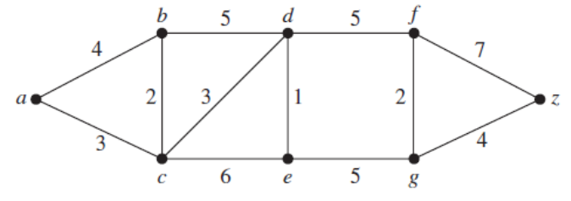 | L3 | CO6 | [7M]
 | b) | Find the minimal spanning tree of the following graph  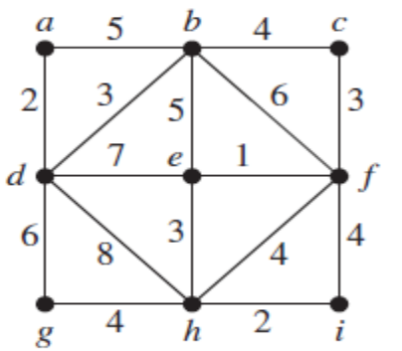 | L3 | CO6 | [7M]
7. | a) | Show that ¬p → (q → r) and q → (p ∨ r) are logically equivalent. | L4 | CO1 | [5M]
 | b) | Find the number of integers between 1 and 1000 inclusive that are divisible by none of 5, 6, and 8 | L3 | CO2 | [5M]
 | c) | Determine whether the poset ({1, 3, 6, 9, 12}, ∣) is a lattice? | L3 | CO3 | [4M]
8. | a) | If (G, ∗) is a group then (a ∗ b)⁻¹ = b⁻¹ ∗ a⁻¹ for all a, b ∈ G | L4 | CO4 | [5M]
 | b) | Solve the following recurrence relation:  a_{n} = 7a_{n−1} − 10a_{n−2} for n ≥ 2, a₀ = 2, a₁ = 1 | L2 | CO5 | [5M]
 | c) | Draw the dual graph for the following graph  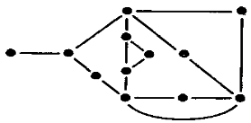 | L2 | CO6 | [4M]

-- 00 -- 00 –

